Balatro Card Visual Effects Suite
Give your card game visuals an instant upgrade with the Balatro Shader Pack—a complete suite featuring cool Foil, Holographic, and Negative shaders, plus handy scripts for smooth card rotations, interactive hover effects, and a dynamic background shader.

Welcome to the Balatro Card Visual Effects Suite! This asset is designed to add some real magic to your Unity card games. Whether you’re looking for that sleek, shiny finish or a futuristic, color-shifting vibe, this pack has you covered. Here’s what you get:
- Foil Shader: Gives your cards a glossy, high-end metallic look.
- Holographic Shader: Creates a mesmerizing iridescent effect that shifts with the light.
- Negative Shader: Flips your card colors for a bold, standout style.
- Balatro Background Shader: Sets an eye-catching scene with dynamic background effects.
- Rotation & Interactivity Scripts: Bring your cards to life with smooth rotations and engaging hover effects.

Shader Details
- Foil Shader
This shader gives your cards a luxe, metallic finish.
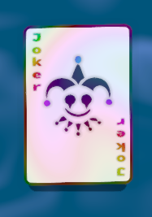

Holographic Shader
Add a futuristic twist with our Holographic Shader. It creates a dynamic, color-shifting effect by simulating light refraction.
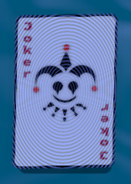
Negative Shader
For a dramatic, high-contrast look, try the Negative Shader. It inverts your card colors to produce a striking effect.
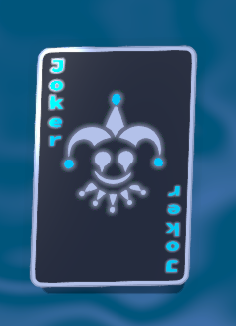
Balatro Background Shader
Transform your entire scene with the Balatro Background Shader. This shader creates a dynamic backdrop that perfectly complements your cards.
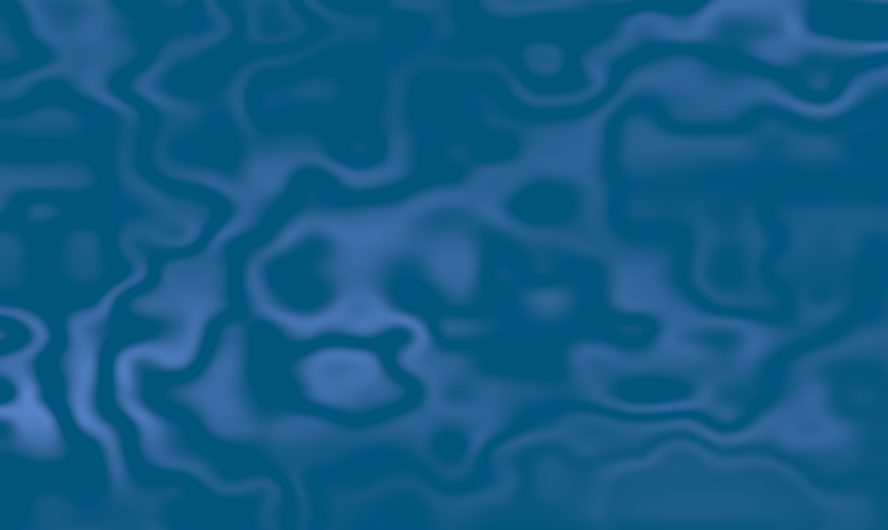
Scripting & Interactivity
Card Rotation Script
This script makes your cards rotate smoothly, adding a touch of elegance to your game.

Customization
All shaders come with easy-to-adjust settings right in Unity’s Material Inspector. You can fine-tune parameters such as glossiness, metallic intensity, and animation speeds to perfectly match your game’s style. Plus, if you’re into advanced customization, these shaders are fully compatible with Unity’s Shader Graph.

Dependencies
This asset requires DOTween to work properly with the rotation and hover effects scripts. Make sure DOTween is installed in your project (available for free on the Unity Asset Store).

Troubleshooting & Support
Common Issues:
- Shader Not Showing: Double-check your graphics settings and ensure the shaders are applied to the correct materials.
- Script Errors: Make sure the scripts are attached to GameObjects that have the necessary components (like a Mesh Renderer for the shader or a Collider for hover effects).
- Stencil Buffer Issues: ShaderGraph currently does not support implementation of a stencil buffer in UI materials. However, there exists a workaround that is detailed at https://github.com/Xeraclom14/ShaderGraph-UI-Masking-Fixer (Big thanks to Xeraclom14). An already fixed material is found in the Holographic folder that fixed the problem (Also shoutout to Dan for making me aware of the problem!).
If you run into any issues, refer to this README or get in touch!
Developed with passion by Line0Games.

